Exercises 1.1.4

1. Go to Settings -> Network & Internet -> Ethernet -> Change adapter options ->  Ethernet Status -> Properties -> Internet Protocol Version 4, and check your  computer’s TCP/IP settings.

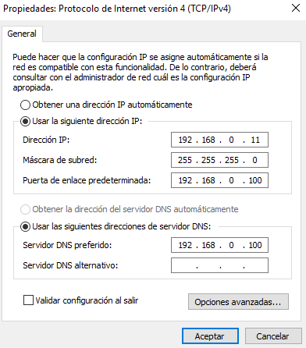

1. Go to Settings -> Network & Internet -> Status -> Network reset. Do not “Reset  now” your network. What happens if you do so?

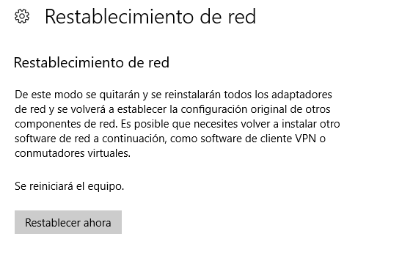

If you give the button, what it will do is leave the factory network card.

1. Go to Task Manager -> More details -> Performance -> Ethernet.

